SYSTEM DOCUMENT

Project: ECSE211 Project Fall 2019
Task: identify and define the solution environment including all the tools and component available for both software and hardware

Document Version Number: Version 1.1
Date: Oct 19th, 2019
Author: Cheng Chen & Tony Ou

Edit History:

Version Number | Date | Author | Description
Version 1.1 | Oct 19th, 2019 | Cheng Chen & Tony Ou | Initial draft
Version 1.2 | Nov 28th, 2019 | Xirui Zhang | Final Update

This document is intended to identify and define the solution environment, i.e. the tools you can use and the basic components you have to construct a solution from. You need to identify the capabilities of all parts that you have – both software and hardware.

The goal of this document is to know everything you need to about the system to be used for implementing the solution to the design problem.

Note that this is going to start as a fairly sketchy document because you don’t know enough. However, it should be iteratively updated as information is learnt about the basic environment in which you have to operate. It should be completed before you can move on to the next stages of the design process. Note – there may be a temptation to repeat information from the Requirements here. you should not do this – instead, you can refer to the appropriate sections of the Requirements. (The reason for this is to try to keep everything synchronized – each item should only appear in one place so that, when an edit occurs, it only has to be edited once otherwise contradictions might appear.)
Table of Contents

1.0 SYSTEM MODEL 2
2.0 HARDWARE AVAILABLE AND CAPABILITIES 3
3.0 SOFTWARE AVAILABLE AND CAPABILITIES 4
4.0 COMPATIBILITY 4
5.0 REUSABILITY 4
6.0 STRUCTURES 5
7.0 METHODOLOGIES 5
8.0 TOOLS 5

1.0 SYSTEM MODEL
To fulfill the goal of the project, “to design and construct a machine that can autonomously navigate a closed course and launch a ping-pong ball into a bin residing at a known location outside the perimeter”, we are planning to build our robot upon the design for lab 5 with some modifications.

Localization: Once the robot identifies its team color, it will localize itself to the corresponding starting point.

Navigation: The robot will be using navigation algorithm when it navigates to the tunnel, navigates to the launch point and returns back to the starting point.

Obstacle Avoidance: To avoidance the fixed obstacles placed on the field and a moving obstacle which is the other player, an extra ultrasonic sensor may be required to be able to detect obstacles from all the directions.

Ball launching: To increase the odd of successfully sinking one ball into the bin, a loader mechanism involving development in both hardware and software will be implemented. Additional materials may be used with prior written approval from the instructors.

Time limit: To achieve the time limit, testing will be highly involved in the development phase to decrease the time needed for each algorithm while maintaining a stable performance.
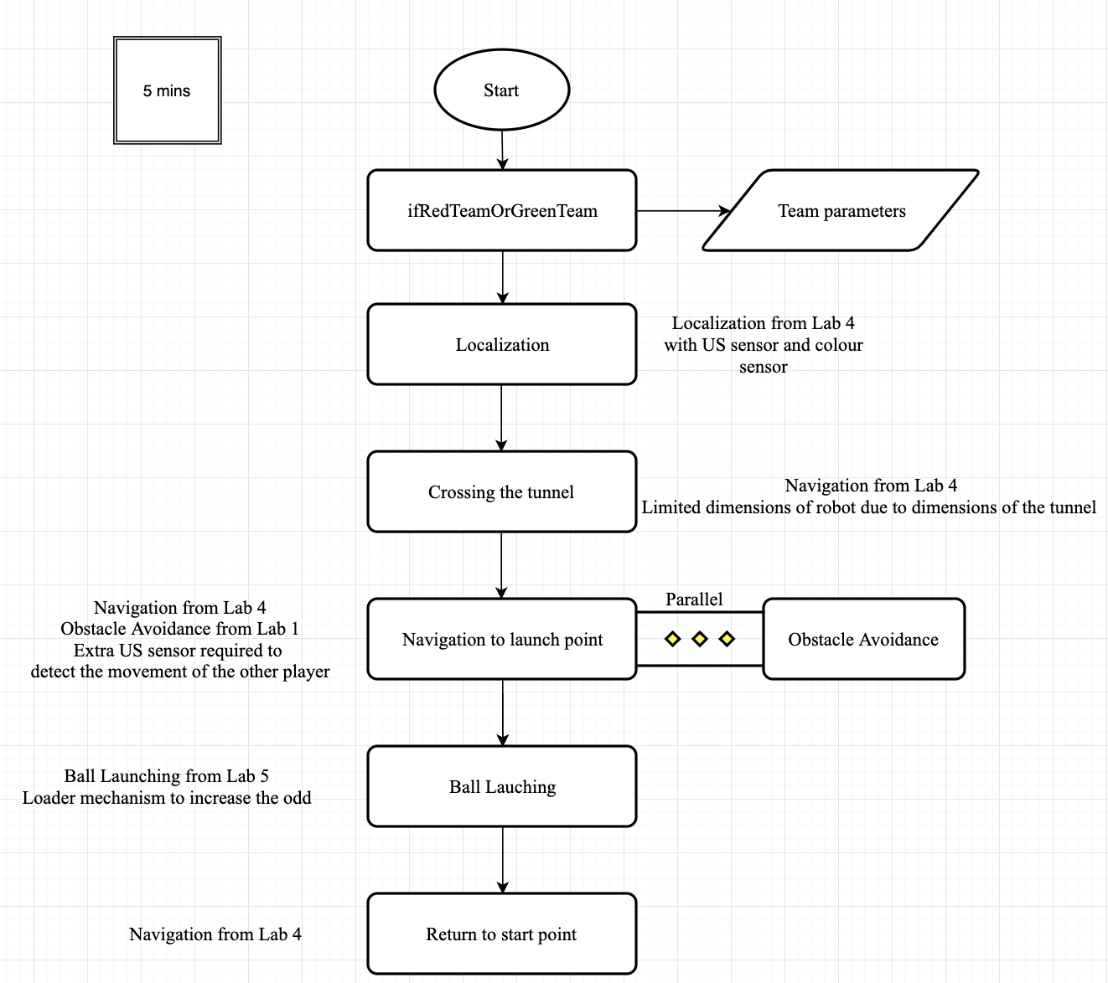
Figure 1. Block Diagram of System Model

- HARDWARE AVAILABLE AND CAPABILITIES
- Lego components
  - Rigid pieces, limited flexibility
  - Limited curvature, defined shapes by the pieces
  - Maximum 4 motors per brick
  - Maximum 4 sensors per brick
- Electromechanical limitations
  - Limited range of sensors (Ultrasonic, touch, color)
  - 3 types of motors (NZXT Large Motor, EV3 Large Motor, EV3 Medium Motor)
  - Motor power limited by battery health
- Electronic/processor constraints
  - Maximum motor speed of 100 x battery voltage
  - Maximum 3 concurrent threads
  - 8kHz speaker quality
  - 300 mHz processor
  - 2050 mAh battery capacity
- SOFTWARE AVAILABLE AND CAPABILITIES
- Java
  - Advantages:
    - Easy to learn and use than alternative programming languages
    - It allows the programmers to create modular programs and reusable codes.
    - It can run on any machine as long as JVM is present.
  - Disadvantages:
    - It has slower performance and is more memory consuming than other programming languages.
    - It does not support low-level programming.

- Eclipse
  - Advantages:
    - It has great features including code completion, syntax checking, and refactoring application.
  - Disadvantages:
    - Various plugins may require different versions which lead to confusion through development.

- Lejos library
- GitHub

4.0 COMPATIBILITY
- Hardware compatibility
  - NZXT and EV3 sensors & motors
- Software compatibility
  - Java built in libraries
  - Lejos classes & methods

5.0 REUSABILITY
- Reusable hardware
  - Base robot setup – Lab 1 (EV3 brick & 2 large motors)
  - Ballistic launcher – Lab 5 (Launcher & 2 large motors)
  - Ultrasonic sensor front component – Lab 1 (US sensor & parts)
  - Color sensor back component – Lab 4 (Color sensor & parts)
- Reusable software
  - Bangbang & PController for obstacle avoidance – Lab 1
  - Odometer class – Lab 2
  - Display class – Lab 2
  - Navigation class – Lab 3
  - Ultrasonic localization class – Lab 4
  - Light localization class – Lab 4
  - Launcher class – Lab 5

6.0 STRUCTURES

- The robot must be able to fit into the tunnel.
- The robot needs to be stable enough to complete the full course.
- One ultrasonic sensor will be installed at the front of the robot for localization and object avoidance. It would be better to have a rotating one to have a larger detection range.
- Two color sensors will be installed facing downwards at the back of the robot for light localization and also odometer correction.
- A ball launcher needs to be built on the robot to shoot the ball.
- The odometer class needs to be a thread to update the odometer at any time during the process.

7.0 METHODOLOGIES

For the design process of software components, please refer to SOFTWARE DESIGN DOCUMENT for details.

8.0 TOOLS

Tool | Description
Trottier DPM Lab | Main site for hardware, software and testing implementation.
Dropbox | Share documents within the team and with the professor for weekly meetings.
Microsoft Office | Microsoft Word for documentation, PowerPoint for weekly meetings and Excel for timeline.
Gantt Project | Used for the group Gantt chart.
Messenger | Communication between teammates

